Lab 3.4: Configure Email Notification in Jenkins

This section will guide you to:

Configure Gmail in Jenkins

This lab has 4 subsections:

3.4.1 Install “Email Extension plugin” in Jenkins.

3.4.2 Configure Gmail in Jenkins.

3.4.3 Receive an email when the Build fails.

3.4.4 Receive an email when the Build is successful.

**Step 3.4.1 :** Install “**Email Extension plugin**” in Jenkins

Go to Jenkins landing page ➔ Manage Jenkins ➔ Manage plugins ➔ Available

Search for the plugin and install it. Once done, you will be able to see it in the list of installed plugins.

**Step 3.4.2 :** Configure Gmail in Jenkins

Go to Jenkins landing page ➔ Configure system ➔ Extended E-mail notification

Fill it up as follows:

SMTP server – ‘smtp gmail.com’

Username – (Your email id)

Password – (Your password)

SMTP port – 465

Reply To List - (Your email id)

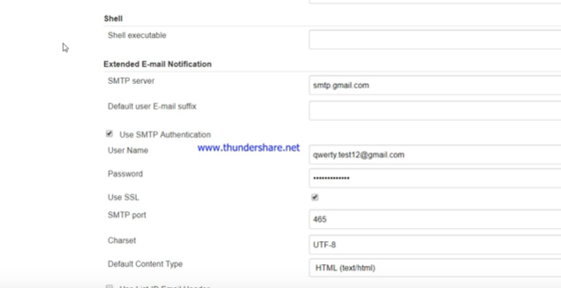

If you realize that you are not receiving emails to your Gmail account, login to your email account and enable “**Allow less secure apps**”.

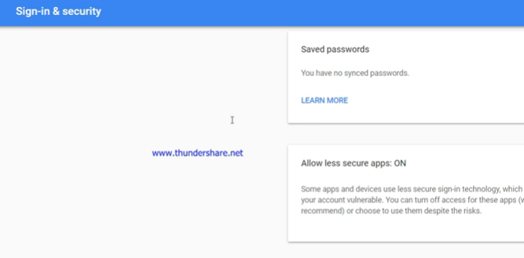

Now, set the following:

Default Subject : $PROJECT_NAME – Build # $BUILD_NUMBER - $BUILD_STATUS!

Default Content : $PROJECT_NAME – Build # $BUILD_NUMBER - $BUILD_STATUS

Check console output at $BUILD_URL to view the results.

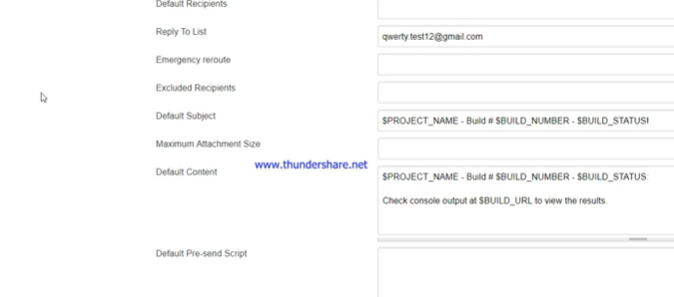

You can click on “**Test Notification**” and check if you have received an email or not.

Then click on “**Save**”.

Create a new job named “TestJob”. Then go to “**Configure**”.

You need to configure so that when the job build fails, you will receive an email.

Go to “**Add post-build action**” ➔ E-mail Notification

Fill in your email id in “**Recipients**”.

You can put multiple email ids by providing a space between consecutive ones.

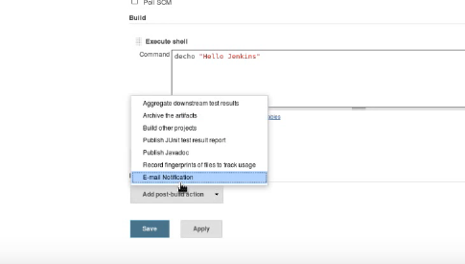

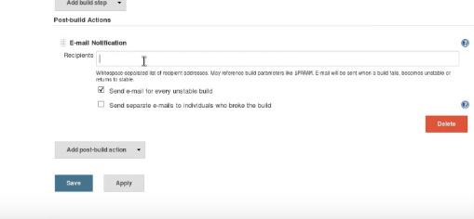

Click on “**Save**”.

**Step 3.4.3 :** Build the project to receive an email

Make some change to your code so that the Build is not successful.

Go to Build Now ➔ Check the output in the console, and make sure that your Build has failed

Now, go to your email id to make sure that you have received an email stating that the Build has failed.

**Step 3.4.4 :** Rectify your mistake, and Build the project to receive an email again

Go to your project, and rectify your mistake in the code so that the Build is successful.

Once done, Build it again, and check if you have received an email stating that the Build was successful.